Summary of CI-CD steps

This is to demonstrate the CI CD for application deployment to existing ECS cluster.

1. Create a ECS cluster ,ECS task definition and ECS service as shown below. If you are not aware of ECS then go through AWS ECS documentation to create the stuff below.

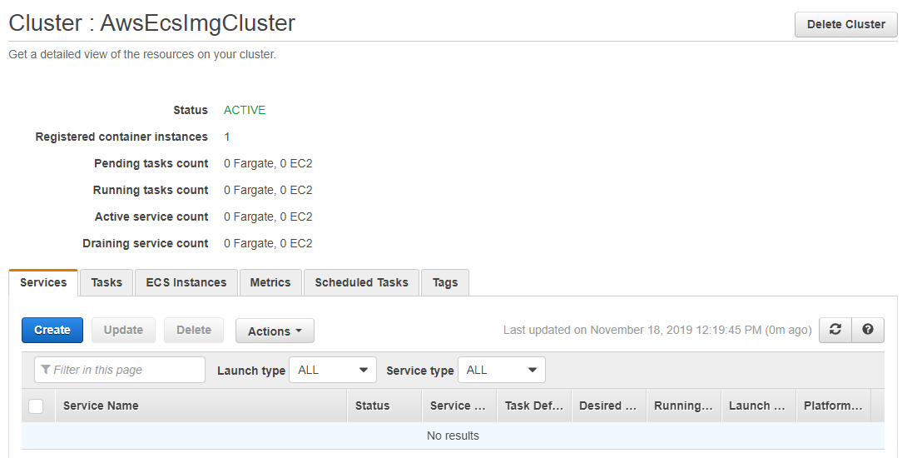

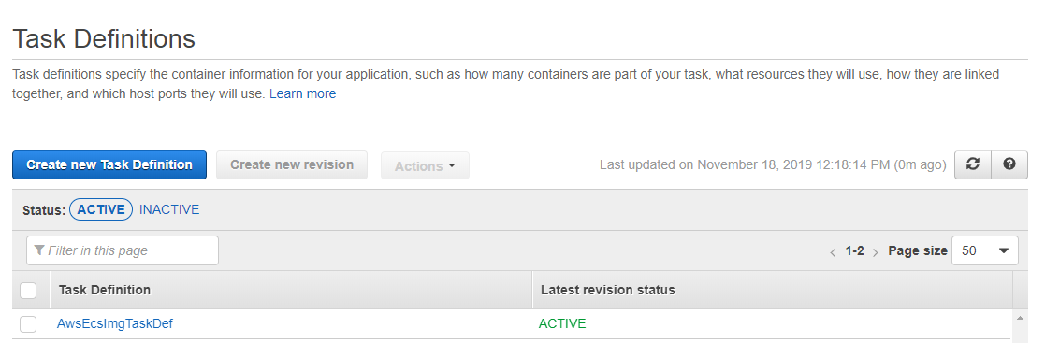

The container name should be same as container name in buildspec.yml file to prepare.

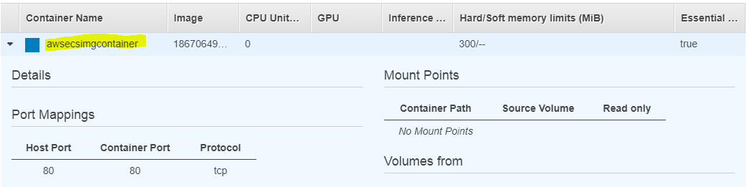

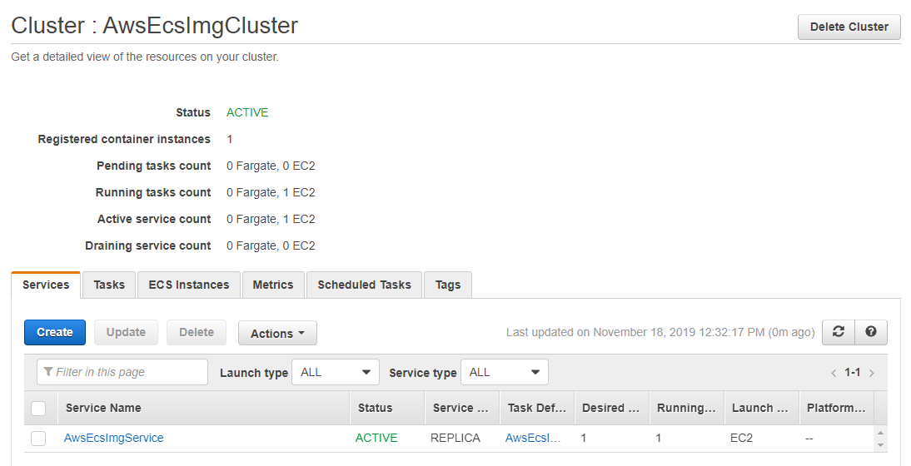

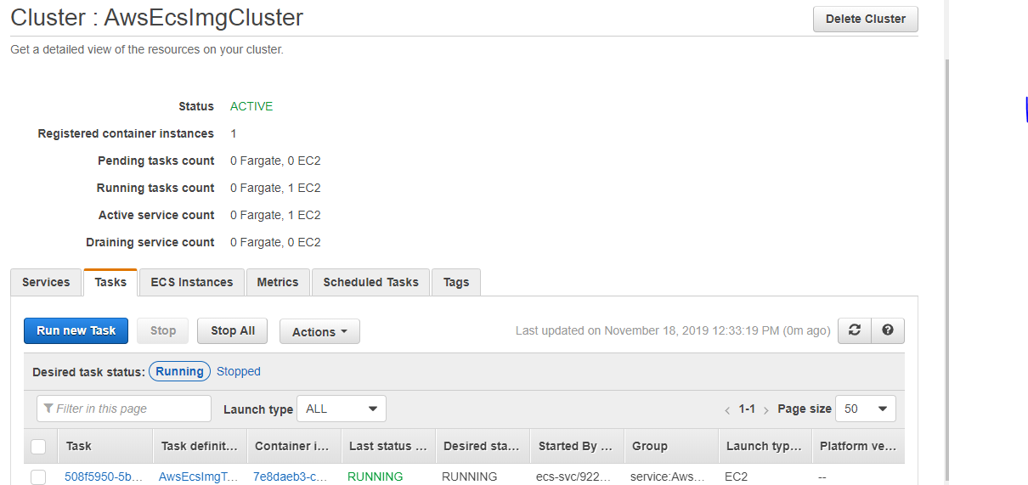

2. Commit your code and build files to CodeCommit repo.

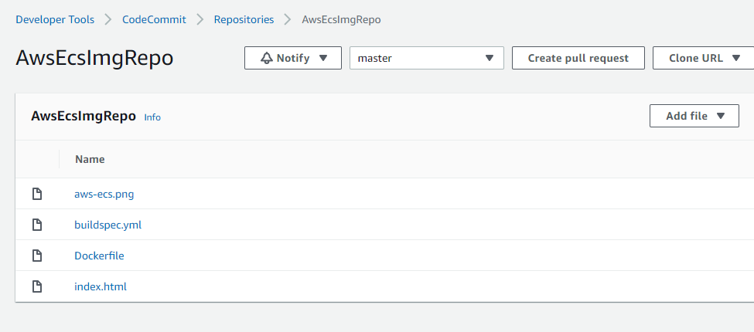

3. Create your CodeBuild project using the code present on CodeCommit Repo.

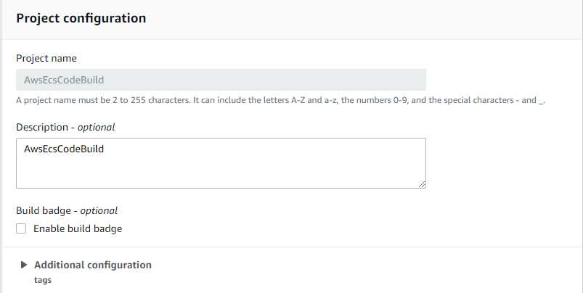

Fill it as shown and click next.

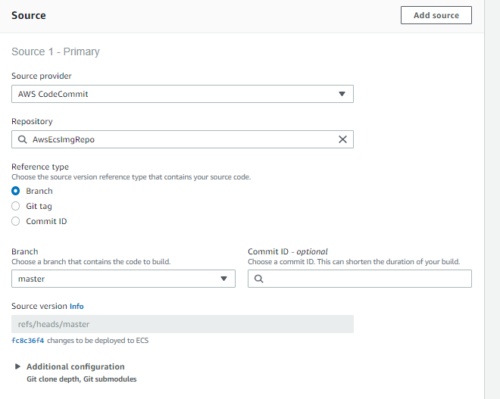

Fill it as shown and click next.

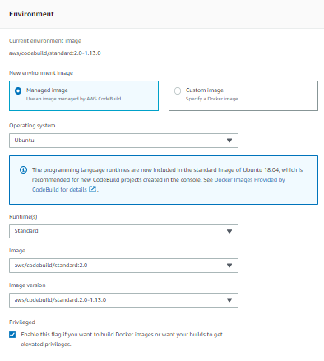

It will automatically pickup buildspec file on your src repo.

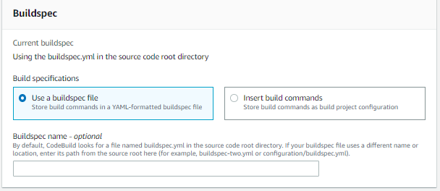

No artifacts needed. Configure cloudWatch logs and Click Create.

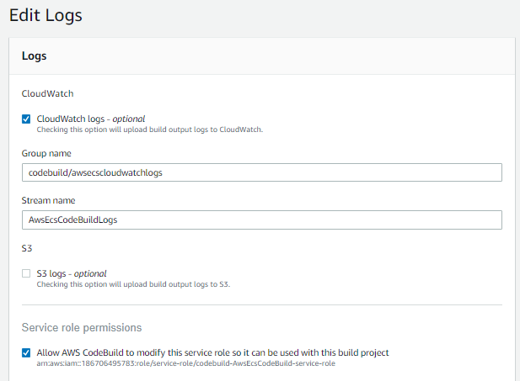

4. Create your Code Pipeline as per the steps below.

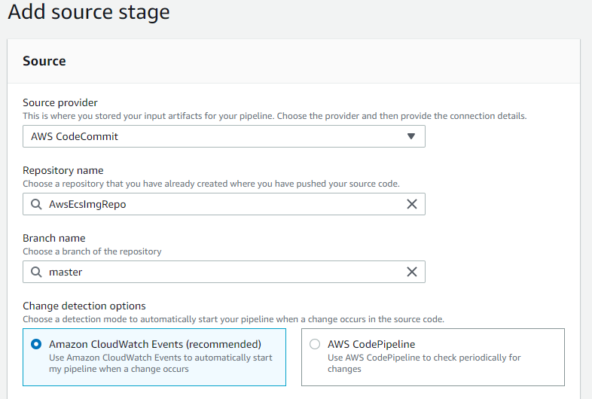

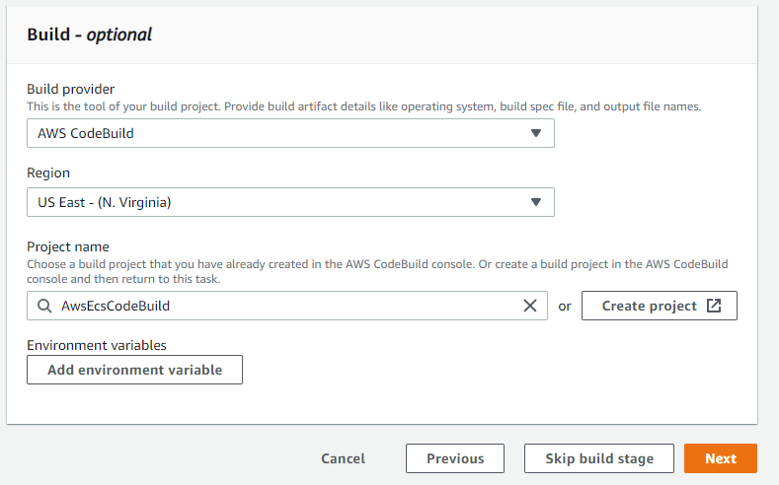

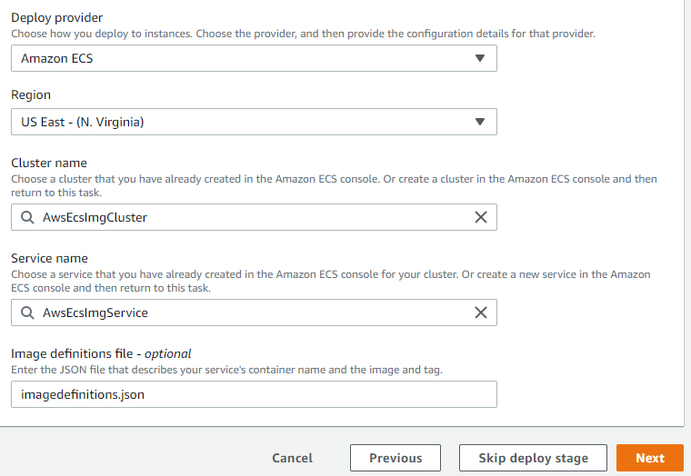

5. Once you create code pipeline , then it will trigger and show you the status of various stages.

Fix errors if any by referring to AWS troubleshooting docs.

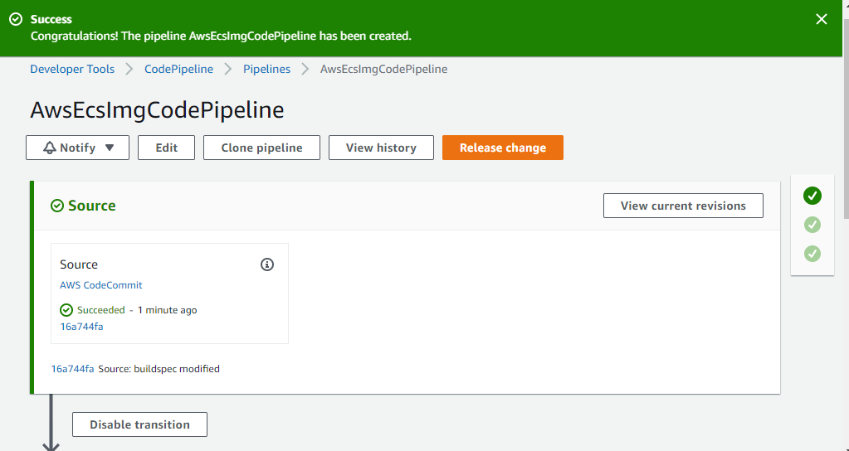

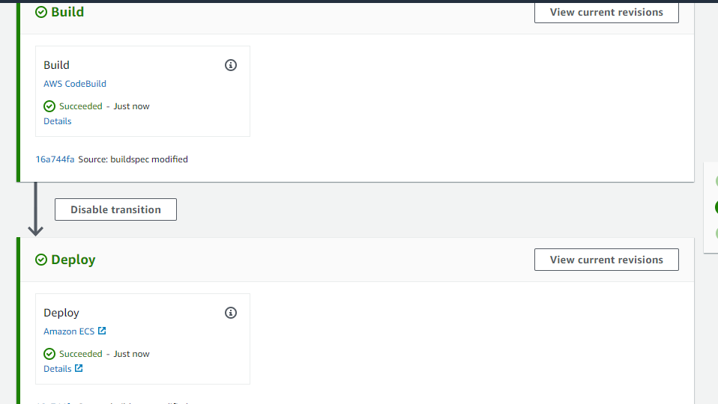

6. Open the public IP of your ECS instance in the browser.

it should show your application home page.

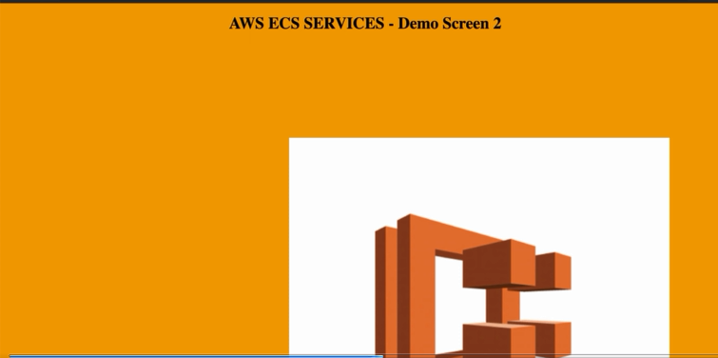

7. To test your auto trigger of code pipeline on code changes in codecommit repo.

Make some changes in your code as below and commit the changes.

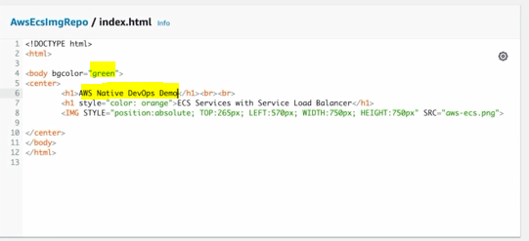

It should auto rigger another round of code pipeline .

Wait for code pipeline to complete.

8. Now open again the public ip of your ecs instance on browser.

It should reflect changes done to your code.

